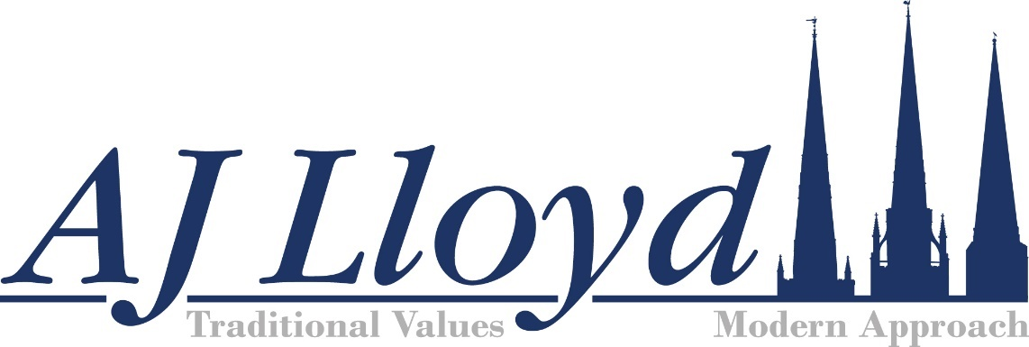

Disclosure of Interests
- The owners of A J Lloyd Funeral Directors Ltd are Darren Lloyd & Karen Lloyd (only).
- There are no business or material financial interest in a price comparison website.
- There has been no material charitable donation to a third party.
- There has been no charitable contribution or payment of gratuity to a third party.
- There has been no material form of payment to a third party that does not relate to a cost incurred or a service provided by the third party on behalf of or to A J Lloyd Funeral Directors Ltd.

